**Functional Document**

|  |  |
| --- | --- |
| **Application** | NGERP - Centra |
| **Service Bundle** | Sales Management |
| **Service Request** | Manage Invoice Approval |

**Description :**

A higher level approval is needed to complete invoices like Sales Credit Memo, Sales Debit Memo and

AR Credit Memo. These invoices can be approved in the Manage Invoice Approval screen by higher level authorities. Only some users have access to this screen in the NGERP – Centra Application.

**Workflow Process :**

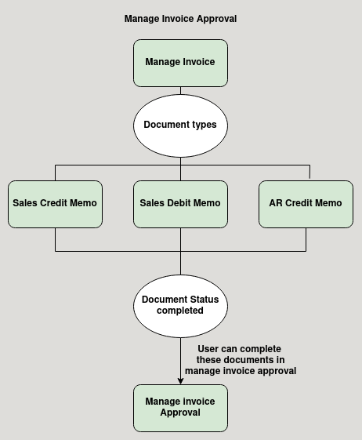

**Business Rules :**

* User with the Manage invoice approval screen and process access can only able to complete the invoices.
* System shows these invoices in manage invoice approval screen:
  + Sales Credit Memo
  + Sales Debit Memo
  + AR Credit Memo
  + Commercial discount invoice
  + 4type’s of manual sales invoice
  + Promotion invoice
* But users can only able to void, reactivate and complete the below documetn:
  + Sales Credit Memo
  + Sales Debit Memo
  + AR Credit Memo
* After reversing the invoice in manage invoice approval screen the invoice will be become draft and does not show in manage invoice approval screen.